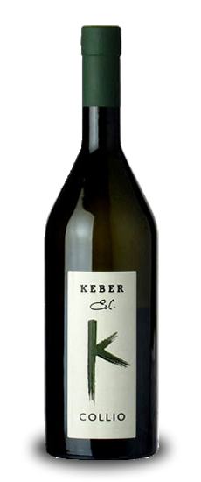
The Characteristics of Collio Bianco Edi Keber
Still white wine, full bodied and intense, smooth and soft, with pleasant fruity and floral scents, aged in cement
Producer Edi Keber
Denomination Collio DOC
Grapes Friulano 70%, Malvasia Istriana 15% e Ribolla Gialla 15%
Region Friuli Venezia Giulia
Alcohol 12,5%
Dimension 75 cl Bottle
Aging In cement for 8 months

The description of the Sommelier
Edi Keber is a landmark in the Collio, one of those producers are capable of lifting a region a world leader in production of white wine. In fact, the quality of whites from Friuli is gaining continued success around the world and Edy Keber is one of those names really essential to know an area. This Collio Bianco was born from the union of three major varieties: in the first place, known by all as the Friulian Tocai, which from the name reflects the close link with the territory. The exquisite harmony of this bottle is complemented by Malvasia and Ribolla Yellow varieties have great potential, who find in this corner of the East their best habitat. If the territory and allow vines to get great results, it is necessary to underscore the merits of those who transform this potential into prized bottles: Edi Keber, one who still believes in the philosophy handed down from old during the cold winter evenings in front of a fireplace , one who knows by heart the recipe for great wines. This Collio Bianco is the perfect opportunity to get a small piece of its history, to be fascinated and appreciate the fine quality of its bottles.

Color Brilliant straw yellow
Aroma Intense scents of white peach, almond and cedar, complex and delicate notes of magnolia
Taste Tasty and juicy, soft and salty, with a long and hot finish

